Answer based on JP Domain Name Dispute Resolution Policy

|  |
| --- |
| ＊Delete the notes portion (written in red) at the time of submission! |

(Note 1) Submit Word file and PDF file of the written answer and PDF file of related documents. Submission shall be made by uploading electronic files on the online storage which this Center has designated. Please note that the total file size of electronic files submitted to the Center shall not exceed 200MB.

To: Director of Japan Intellectual Property Arbitration Center

Subject of JP Domain Name in Dispute

＊＊＊＊＊＊. JP

**Registrant**

Name (Title):

Domicile:

Telephone Number:

Fax Number:

E-mail Address:

(Note 2) In the case where there is nothing to be filled in any entry, state “not applicable” or “unknown” as appropriate without removing the entry-title.

(Note 3) In the case where the Registrant is a juridical person, describe the name of the representative of the Registrant and submit by PDF file, the copies of the official certificates evidencing the authority to represent such juridical person (issued within 3 months prior to the submission date of Complaint) such as Certificate of Qualification of Representative, Certified Copy of Commercial Registration, etc. (If such official certificates are not available, submit notarized corporate nationality certificate, or other alternative evidence.)

**Complainant**

Name (Title):

Domicile:

Telephone Number:

Fax Number:

E-mail Address:

**1. Registrant’s preferred method of communication.**

(A) Communication by e-mail

E-mail Address:

Name of contact person:

(B) Communication by postal service

Postal Address:

Name of contact person:

(Note 4) In the case where the number of Registrants is two or more, the above information of each Registrant shall be described. Explain the relationship between the Registrants and the reasons that each Registrant has interests in the subject JP domain name in the dispute.

(Note 5) In the case where the agent is assigned, the above information is not necessary. Describe as “See the contact information of the Agent in 2 below.”

1. **Agent for Registrants of the dispute resolution proceedings**

Name (Title):

(Note 6) Fill in the name of attorney at law or patent attorney admitted in Japan.

Postal Address:

(Note 7) Fill in the postal address including the name of law firm or patent firm.

Telephone Number:

Fax Number:

E-mail Address:

(Note 8) The power of attorney shall be submitted by PDF file.

(Note 9) In the case where the number of agents is two or more, the above information for each agent and one agent as an adressee shall be filled in.

1. **Answer to statements and allegations in the written complaint**

(Article 4, Paragraphs (a), (b), and (c) of Policy, Article 5 of Procedural Rules)

With respect to the Complainant’s statements and allegations in the written complaint, the reasons and bases for the registrant to retain registration and use of the subject domain name are as follows.

1. Rebuttal to the Complainant’s opinion that the domain name of the Registrant is identical or confusingly similar to the trademark and other indication in which the Complainant has rights or legitimate interests;
2. Rebuttal to the Complainant’s opinion that the Registrant has no rights or legitimate interests with respect to the domain name; and
3. Rebuttal to the Complainant’s opinion that the domain name of the Registrant has been registered or is being used in bad faith (unfair purpose).

Registrant certifies that the information contained in this written answer is complete and accurate to the best of Registrant's knowledge and that this answer is not being presented for any improper purpose, such as to harass.

(Note 10) Include the following matters in a written answer, pursuant to Article 5, Paragraph (b), Item (i) of Procedural Rules.

1. Rebuttal to the Complainant’s opinion that the domain name of the Registrant is identical or confusingly similar to the trademark and other indication in which the Complainant has rights or legitimate interests;
2. Rebuttal to the Complainant’s opinion that the Registrant has no rights or legitimate interests in respect of the domain name; and
3. Rebuttal to the Complainant’s opinion that the domain name of the Registrant has been registered or is being used in bad faith (unfair purpose).

(Note 11) In the discussion of (2) and (3) above, particular attention should be given to the content of provisions of Article 4, Paragraphs (b) and (c) of “Policy.”

Especially, in the case where any of the following circumstances are present, the registration or use of the domain name is considered to have been done in bad faith.

1. where the Registrant has registered or has acquired the domain name primarily for the purpose of selling, renting, or otherwise transferring the domain name to the Complainant or to a competitor of that Complainant, for valuable consideration in excess of the out-of-pocket costs (amount to be confirmed by documentation) directly related to the domain name;
2. where the Registrant has registered the domain name in order to prevent the Complainant from using any trademarks or other indication to which the Complaint has the rights as its domain name, provided that the Registrant has engaged in multiple cases of such interference;
3. where the Registrant has registered the domain name primarily for the purpose of disrupting the business of a competitor; or
4. where the Registrant uses the domain name, for commercial gain, in order to attract Internet users to the web site or other on-line location of the Registrant, with the intention of making a confusion as to the source, sponsorship, affiliation, or endorsement of the web site or other on-line location, or of a product or service thereon.

In addition, especially, in the case where any of the following circumstances are present, it is considered that the registrant holds the rights or legitimate interests to the domain name.

1. where before the Registrant receives any notice of the dispute related to the subject domain name by any third party or the dispute-resolution service provider, the Registrant uses, or apparently demonstrates preparations to use, the domain name or a name corresponding thereto, in order to offer goods or services without any bad faith (unfair purpose);
2. where the Registrant has been commonly known by any name under the domain name, regardless of registration or others by the Registrant of any trademark and other indications; or
3. where the Registrant is using the domain name for a noncommercial purpose or is making fair use of the domain name, without intent for commercial gain to misleadingly divert consumers by utilizing the trademark and other indications of the Complainant or to tarnish any trademark and other indications of the Complainant.

(Note 12) Answer to the statements and allegations in a written complaint shall be written within 10,000 characters in Japanese (including punctuation).

(Note 13) Please submit by PDF file, the copies of any evidence including documentary evidences upon which the Registrant relies in the written answer or rebuttal, a list of such evidence and a written explanation of such evidences.

1. **Domain Name Dispute Resolution Panel**

(Article 5, Paragraph (b), Item (iv) of Procedural Rules)

Registrant elects to have these dispute resolution proceedings examined and decided by member panel.

(Note 14) Select whether a single member panel or a three member panel.

(Note 15) In the case where a three member panel is selected, the names of three candidates (they shall be drawn from any list of panelists publicized by approved dispute-resolution providers) shall be listed below.

1. **Other Legal Proceedings**

(Article 5, Paragraph (b), Item (vi) of Rules)

(Note 16) Describe the summary of any other legal proceedings that have been commenced or terminated in connection with or relating to the subject domain name in the written complaint and the subject issues in such proceedings, below.

1. **Payment**

Registrant has paid (will pay) 180,000 yen (plus consumption tax) pursuant to the fee rules, which is a part of the supplementary rules of this Center.

Date of Remittance:

Name of Bank:

Name of Main or Branch Office of Bank:

Name of Remitter:

(Note 17) Registrant shall pay 180,000 yen (plus consumption tax) when the Registrant selects the number of panelists from one to three. In the case where the Complainant selects a single member panel and the Registrant consents to such selection, and where the Complainant selected a three member panel, the payment is not required.

[End of Text]

Name of Registrant (or Agent) (with an electronic signature or name and seal (in any format)):

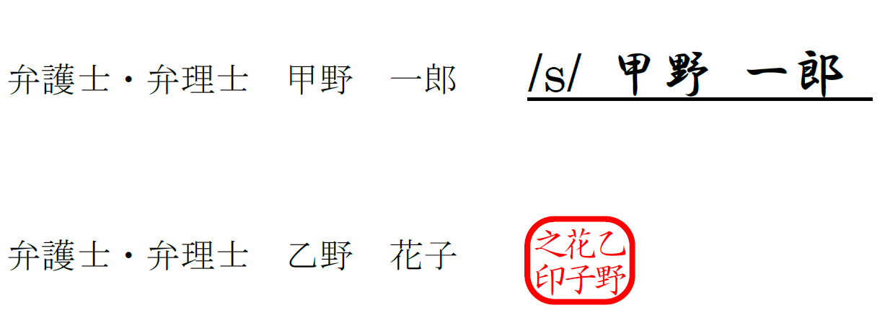

E-mail Address:

Submission Date:

(Note 18) The electronic signature or name and seal of the Registrant or its authorized agent are required, but any format of electronic signature or name and seal will be accepted. The issuance of electronic authentication is not necessary, and it is enough for the signor to show the intent to sign. Examples of electronic signature or name and seal are as follows:

* Scanned PDF file of the hard copy of pages including concluding statement and with handwritten signature or name and seal.
* PDF file including concluding statement and with electronic signature by using digital signature function of Adobe or other software.
* Word file including concluding statement and with electronic signature by using digital signature function of Microsoft Word or other software.
* Word file including concluding statement and copied and pasted the picture file of handwritten signature or name and seal and its converted PDF file.
* Word file including concluding statement and with /s/ (Name of Signor) (typing /s/ before a person’s name on the signature line) and its converted PDF file.

Submission of both Word file and PDF file of the written answer is necessary, but electronic signature may be attached to either of the files.