Complaint based on JP Domain Name Dispute Resolution Policy

|  |
| --- |
| ＊Delete the portion of notes (written in red) at the time of submission! |

(Note 1) Submit Word file and PDF file of the written complaint and PDF file of related documents. Submission shall be made by uploading electronic files on the online storage which this Center will designate after Complainant’s sending an email which includes the information of the parties and the JP domain name in question to the Center. Please note that the total file size of electronic files submitted to the Center shall not exceed 200MB.

To: Director of Japan Intellectual Property Arbitration Center

Subject of JP Domain Name in Dispute

＊＊＊＊＊＊. JP

**Complainant**

Name (Title):

Domicile:

Telephone Number:

Fax Number:

E-mail Address:

(Note 2) In the case where there is nothing to be filled in any entry, state “not applicable” or “unknown” as appropriate without removing the entry-title.

(Note 3) In the case where the Complainant is a juridical person, describe the name of the representative of the Complainant and submit by PDF file, the copies of the official certificates evidencing the authority to represent such juridical person (issued within 3 months prior to the submission date of written complaint) such as Certificate of Qualification of Representative, Certified Copy of Commercial Registration, etc. (If such official certificates are not available, submit notarized corporate nationality certificate, or other alternative evidence.)

**Registrant**

Name (Title):

Domicile:

Telephone Number:

Fax Number:

E-mail Address:

**1. Registrant’s preferred method of communication.**

(A) Communication by e-mail

E-mail Address:

Name of contact person:

(B) Communication by postal service

Postal Address:

Name of contact person:

(Note 4) In the case where the number of Complainants is two or more, the above information of each Complainant shall be described. Explain the relationship between the Complainants and the reasons that each Complainant has interests in the subject JP domain name in the dispute.

(Note 5) In the case where the agent is assigned, the above information is not necessary. Describe as “See the contact information of the Agent in 2 below.”

1. Agent for Complainant of the dispute resolution proceedings

Name (Title):

(Note 6) Fill in the name of attorney at law or patent attorney admitted in Japan.

Postal Address:

(Note 7) Fill in the postal address including the name of law firm or patent firm.

Telephone Number:

Fax Number:

E-mail Address:

(Note 8) The power of attorney shall be submitted by PDF file.

(Note 9) In the case where the number of agents is two or more, the above information of each agent and one agent as an addressee shall be filled in.

1. All Registrant contact information (except the above) known to the Complainant.
2. Grounds for the Complaint

(Article 4, Paragraphs (a), (b), and (c) of Policy, Article 3 of Procedural Rules)

Complainant requests that this complaint be examined and decided in accordance with JP Domain Name Dispute Resolution Policy and Procedural Rules for the same. This complaint is based on the following.

1. the domain name of the Registrant is identical or confusingly similar to the trademark and other indication in which the Complainant has rights or legitimate interests;
2. the Registrant has no rights or legitimate interests in respect of the domain name; and
3. the domain name of the Registrant has been registered or is being used in bad faith (unfair purpose).

Complainant agrees that its claims and remedies concerning the registration of the domain name, the dispute, or the dispute's resolution shall be solely against the Registrant and waives all such claims and remedies against (a) the dispute-resolution provider and panelists, (b) JPRS itself, directors, officers, employees of JPRS and other persons concerned, and (c) JPNIC itself, directors, officers, employees, committee members of JPNIC and other persons concerned, except in the case of deliberate wrongdoing.

Complainant certifies that the information contained in this written complaint is to the best of Complainant's knowledge complete and accurate, that this complaint is not being presented for any improper purpose, such as to harass.

(Note 10) Describe that the subject domain name in the written complaint is registered with JPRS at the time the written complaint is filed (such as by showing the search result of JPRS WHOIS), and explain the trademark or other indication on which the written complaint is based, and the nature and content of the goods or services, if any, with which the trademark or indication is used, pursuant to Article 3, Paragraph (b), Items (vii) and (viii) of Procedural Rules. If there are other goods and services with which the Complainant intends to use the mark in the future, describe to that effect. Attach a duplicate of a certificate of registration of the relevant trademark, etc.

(Note 11) Explain concretely the grounds for the written complaint including the following matters, pursuant to Article 3, Paragraph (b), Item (ix) of Procedural Rules.

1. the domain name of the Registrant is identical or confusingly similar to the trademark and other indication in which the Complainant has rights or legitimate interests;
2. the Registrant has no rights or legitimate interests in respect of the domain name; and
3. the domain name of the Registrant has been registered or is being used in bad faith (unfair purpose).

(Note 12) In the discussion of (2) and (3) above, particular attention should be given to the content of provisions of Article 4, Paragraphs (b) and (c) of “Policy.”

Especially, in the case where any of the following circumstances are present, the registration or use of the domain name is considered to have been done in bad faith.

1. where the Registrant has registered or has acquired the domain name primarily for the purpose of selling, renting, or otherwise transferring the domain name to the Complainant or to a competitor of that Complainant, for valuable consideration in excess of the out-of-pocket costs (amount to be confirmed by documentation) directly related to the domain name;
2. where the Registrant has registered the domain name in order to prevent the Complainant from using any trademarks or other indication to which the Complainant has the rights as its domain name, provided that the Registrant has engaged in multiple cases of such interference;
3. where the Registrant has registered the domain name primarily for the purpose of disrupting the business of a competitor; or
4. where, the Registrant uses the domain name, for commercial gain, in order to attract Internet users to the web site or other on-line location of the Registrant, with the intention of making confusion as to the source, sponsorship, affiliation, or endorsement of the web site or other on-line location, or of a product or service thereon.

In addition, especially, in the case where any of the following circumstances are present, it is considered that the registrant holds the rights or legitimate interests to the domain name.

1. where before the Registrant receives any notice of the dispute related to the subject domain name by any third party or the dispute-resolution service provider, the Registrant uses, or apparently demonstrates preparations to use, the domain name or a name corresponding thereto, in order to offer goods or services without any bad faith (unfair purpose);
2. where the Registrant has been commonly known by any name under the domain name, regardless of registration or others by the Registrant of any trademark and other indications; or
3. where the Registrant is using the domain name for a noncommercial purpose or is making fair use of the domain name, without intent for commercial gain to misleadingly divert consumers by utilizing the trademark and other indications of the Complainant or to tarnish any trademark and other indications of the Complainant.

(Note 13) The grounds for the written complaint shall be written within 10,000 characters in Japanese (including punctuation).

(Note 14) Please submit by PDF file, the copies of any documentary evidences including trademark registration upon which the written complaint relies, and a list and a written explanation of such evidences.

1. Remedies Sought

(Article 3, Paragraph (b), Item (x) of Procedural Rules)

Complainant demands that the panel appointed in these dispute resolution proceedings make a decision of with respect to the subject domain name in the dispute.

(Note 15) Select between transfers and cancellations.

1. Domain Name Dispute Resolution Panel

(Article 3, Paragraph (b), Item (iv) of Procedural Rules)

Complainant elects to have these dispute resolution proceedings examined and decided by member panel.

(Note 16) Select whether a single member panel or a three member panel.

(Note 17) In the case where a three member panel is selected, the names of three candidates (they shall be drawn from any list of panelists publicized by approved dispute-resolution providers) shall be listed below.

1. Other Legal Proceedings

(Article 3, Paragraph (b), Item (xi) of Procedural Rules)

(Note 18) Describe the summary of any other legal proceedings that have been commenced or terminated in connection with or relating to the subject domain name in the written complaint and the subject issues in such proceedings, below.

1. Payment

Complainant has paid (will pay) [180,000 / 360,000] yen (plus consumption tax) pursuant to the fee rules which is a part of the supplementary rules of this Center.

Date of Remittance:

Name of Bank:

Name of Main or Branch Office of Bank:

Name of Remitter:

(Note 19) Complainant shall pay 180,000 yen (plus consumption tax) for a single member panel, or 360,000 yen (plus consumption tax) for a three member panel.

(Note 20) Fill in the Date of Remittance with the date within 10 days (business days) from the Submission Date.

1. Complainant’s designation of agreed jurisdictional court and consent for response to action.

(Article 3, Paragraph (b), Item (xii) of Procedural Rules)

Complainant specifies as the agreed jurisdictional court to which the Registrant may submit any challenges against a decision of cancellation or transfer of the domain name, and consents to respond to action when any challenges are submitted thereto.

(Note 21) Select from Tokyo District Court or a jurisdictional court of the domicile of the Registrant of domain name.

[End of Text]

Name of Complainant (or Agent) (with an electronic signature or name and seal (in any format)):

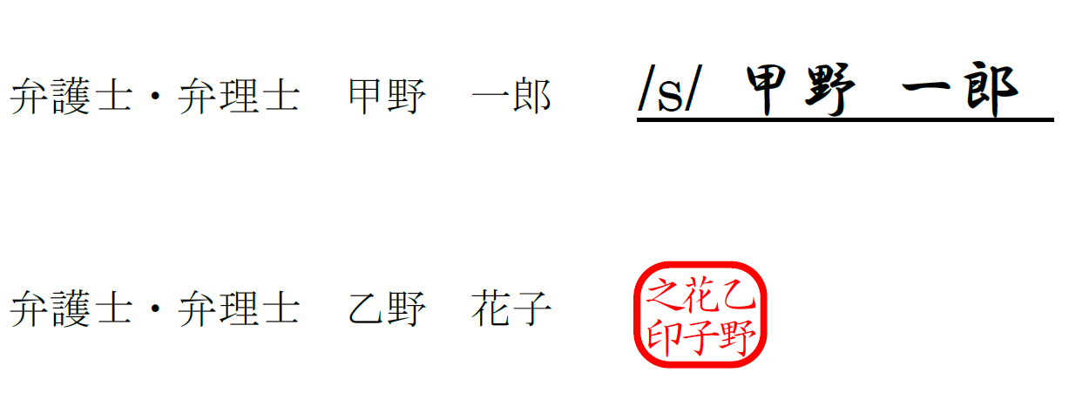

E-mail Address:

Submission Date:

(Note 22) The electronic signature or name and seal of the Complainant or its authorized agent are required, but any format of electronic signature or name and seal will be accepted. The issuance of electronic authentication is not necessary, and it is enough for the signor to show the intent to sign. Examples of electronic signature or name and seal are as follows:

* Scanned PDF file of the hard copy of pages including concluding statement and with handwritten signature or name and seal.
* PDF file including concluding statement and with electronic signature by using digital signature function of Adobe or other software.
* Word file including concluding statement and with electronic signature by using digital signature function of Microsoft Word or other software.
* Word file including concluding statement and copied and pasted the picture file of handwritten signature or name and seal and its converted PDF file.
* Word file including concluding statement and with /s/ (Name of Signor) (typing /s/ before a person’s name on the signature line) and its converted PDF file.

Submission of both Word file and PDF file of the written complaint is necessary, but electronic signature may be attached to either of the files.